Overview
Part J addresses a category of risk that doesn't fit neatly into the access control, encryption, or logging frameworks covered in earlier parts. AI and ML systems introduce a distinct failure mode: even when data is properly encrypted, access-controlled, and logged, the outputs of an AI model can themselves cause harm — to a farmer's finances, to their trust in the platform, or to their legal protections under the DPDP Act.
A crop health model that tells a farmer "your yield will definitely fail" is not a data breach in the technical sense, but it can cause real financial harm if the farmer acts on it (selling land, taking a loan, abandoning a field) and the prediction turns out to be wrong — which AI predictions, by nature, sometimes are. Similarly, sending a farmer's name and exact GPS coordinates to a third-party AI API is a data minimisation failure even if the API itself is secure.
This part covers:
- What AI/ML use cases are appropriate for Eartigo
- A protection checklist for how farmer and farm data flows into AI systems
- Specific guidance on AI output language — what to avoid and what to say instead
- Ethical boundaries on how drone and satellite-derived AI insights can be used
- Implementation code for data minimisation, output review gating, explainability, and prompt log redaction

Safe AI Usage for Eartigo
Eartigo may use AI/ML for the following purposes. Each of these is a legitimate, valuable use of AI in precision agriculture — the goal of this part is not to discourage AI usage, but to ensure it is implemented safely.
- Crop disease and pest detection from satellite or drone imagery
- Yield estimation and harvest prediction
- Soil health analysis and irrigation advisory
- Market price prediction and sell-time recommendations
- Buyer preference matching and product recommendations
- Fraud detection in farmer payouts

Risk Profile by Use Case
Not all six use cases carry the same risk. The team should apply proportionally more scrutiny to use cases where an incorrect AI output could cause direct financial harm to a farmer.
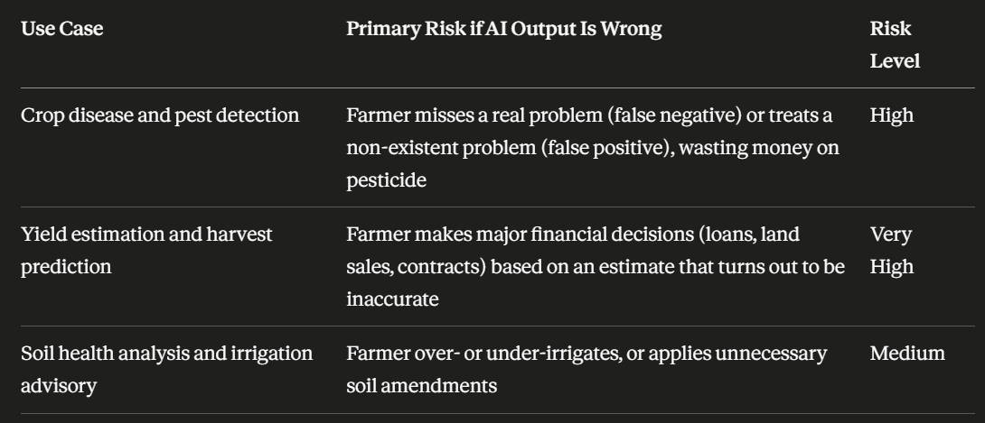
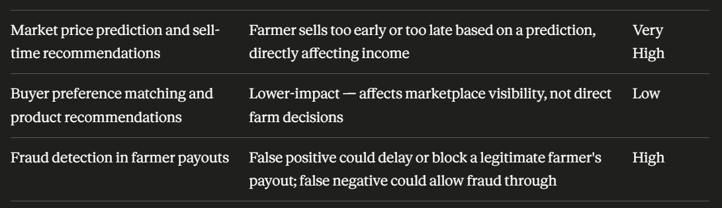

The two "Very High" risk use cases — yield estimation and market price/sell-time recommendations — are exactly the ones where the "Human review for decisions affecting income" checklist item (below) is non-negotiable.

AI Data Protection Checklist

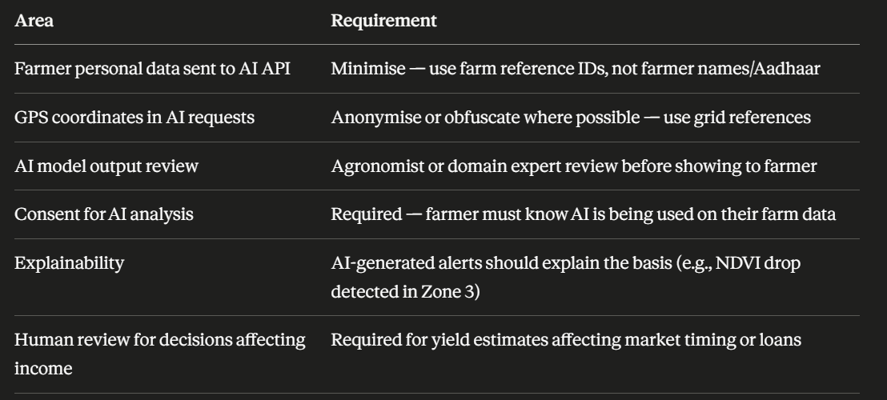
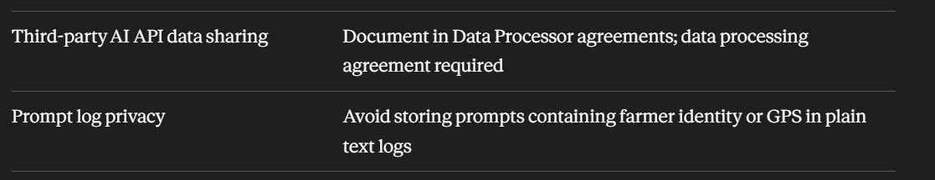

Detailed Guidance for Each Checklist Area
Farmer personal data sent to AI API — When Eartigo's backend constructs a request to an AI/ML service (whether internally hosted or a third-party API), the payload should reference the farm by an internal farm_ref identifier rather than including the farmer's name, phone number, or Aadhaar status. The AI model needs to know which field it's analysing, not whose field it is — those are separable pieces of information, and only the application layer (which has already passed through the RBAC and ownership checks from Part C) needs to reconnect the farm_ref to a specific farmer when displaying results.
GPS coordinates in AI requests — Full-precision GPS boundary polygons (the commercially sensitive data described in Part A) should not be sent to AI services in raw form if it can be avoided. Where the AI task can be satisfied with a coarser spatial reference — a grid cell ID, a bounding box rounded to a lower precision, or a pre-cropped imagery tile that doesn't itself encode global coordinates — that should be preferred. This is especially important for third-party AI APIs, which become Data Processors under the DPDP Act the moment they receive this data.
AI model output review — Before an AI-generated assessment (a pest alert, a yield estimate, a soil recommendation) is shown to a farmer, it should pass through a review step. For high-risk use cases (yield estimation, market timing), this should be a human agronomist or domain expert. For lower-risk, high-volume use cases (routine pest detection alerts), this may be an automated confidence-threshold gate combined with periodic human spot-checks — but the system should be designed so that low-confidence outputs are flagged rather than presented to the farmer as confident fact.
Consent for AI analysis — This connects directly to Part E's consent framework. The "AI-based crop analysis" consent type described there must be captured before any AI processing occurs on a farmer's data, and the consent notice must explain — in plain language — that an algorithm, not a person, is generating the analysis.
Explainability — An alert that says "Pest risk: High" gives the farmer no actionable information and no way to evaluate whether the alert seems plausible based on what they're observing in their field. An alert that says "Pest risk: High — based on a 23% drop in NDVI in the northeast section of your field over the past 7 days, consistent with early-stage pest stress" gives the farmer something they can verify by walking to that part of their field, and gives them confidence the system is looking at real, relevant signals.
Human review for decisions affecting income — Yield estimates that might influence whether a farmer takes a loan, signs a forward contract, or decides to sell land must not be presented as a final, confident number without a human review step. This doesn't mean every individual estimate needs manual sign-off — it can mean the model and its confidence calibration are reviewed periodically by an agronomist, and that any individual estimate crossing certain thresholds (very high or very low relative to historical baseline) triggers a flag for review before being shown.
Third-party AI API data sharing — If Eartigo uses an external AI/ML API (for image analysis, NLP, or any other function) that receives farm-related data, that vendor is a Data Processor under the DPDP Act framework established in Part B. A Data Processing Agreement must be in place covering what data is sent, how long the vendor retains it, whether it's used to train the vendor's own models (this should generally be prohibited unless under a separate, explicit consent), and data deletion on contract termination.
Prompt log privacy — If Eartigo uses LLM-based services (for generating advisory text, summarising agronomist notes, or any natural-language AI feature), the prompts sent to these models — and any logs of those prompts — must not contain farmer names, Aadhaar references, or raw GPS coordinates in plain text. This is the AI-era equivalent of the "What Must NEVER Be Logged" table from Part H, and the same redaction principles apply.

Avoid These AI Outputs for Farmers
AI-generated text shown to farmers must be framed as informational and advisory, never as a definitive prediction of outcome — particularly for anything related to financial risk, creditworthiness, or land value. The framing matters because farmers may not have the technical background to independently calibrate how much confidence to place in an AI system's language, so the system's own framing carries significant weight.
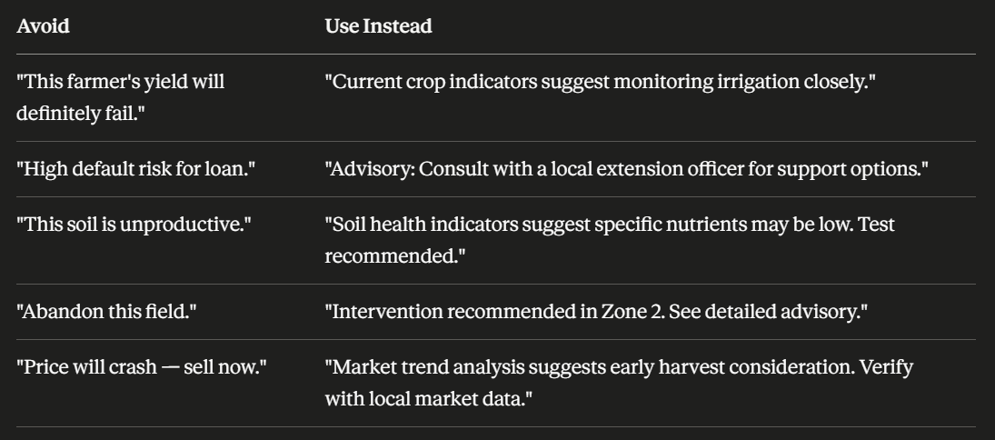

The Pattern Behind These Examples
Looking across all five pairs, the "Avoid" column shares three characteristics: it states a prediction as certain ("will definitely fail", "will crash"), it makes a judgment that sounds final or evaluative ("unproductive", "abandon"), and it implies the AI has assessed something it likely cannot fully assess (creditworthiness, market timing with certainty).
The "Use Instead" column shares the opposite characteristics: it describes what the data shows ("indicators suggest"), it points to a specific, localised observation ("Zone 2", "Zone 3") rather than a global judgment about the whole farm or farmer, and it directs the farmer toward a next step involving a human (extension officer, local market verification) rather than presenting the AI's output as the final word.
This pattern should be encoded as a review standard for anyone writing AI prompt templates or output formatting logic — not just applied ad-hoc to these five examples.

Drone & Satellite Data Ethics
Drone & Satellite Data Ethics
Farm imagery must not be shared with insurance companies, banks, or government bodies without explicit, specific farmer consent for each such purpose. Data collected for crop advisory must not be repurposed for credit scoring, land valuation disputes, or tax assessments without separate consent and legal basis.
This connects directly to two earlier parts. Part A flagged that crop health assessments "must not be used for discriminatory insurance pricing without consent" and that historical yield estimates are "farmer proprietary." Part E's consent framework requires that any sharing with insurance, financial, or government bodies be covered by a separate, purpose-specific consent — not bundled into the general AI analysis consent.
The practical implication for the development team is that the system must be architecturally capable of enforcing this separation — it is not enough for it to be a policy written in a document if the database and APIs make it trivial to query crop health data alongside farmer identity and export it for a purpose the farmer never consented to. The implementation sections below include a data_classification and purpose-gating pattern that supports this enforcement.

Implementation — Data Minimisation for AI Requests

Step 1 — Farm Reference Abstraction Layer
Before any data is sent to an internal AI service or third-party AI API, it should pass through an abstraction layer that strips identity and replaces precise location data with the minimum necessary for the task.
// services/aiDataMinimizer.js

/**
* Prepares farm data for an AI request by stripping farmer identity
* and reducing GPS precision based on the task's actual requirements.
*/
function prepareFarmDataForAI(farm, task) {
const payload = {
farm_ref: farm.farm_ref, // internal reference ID — never expose farmer_id or farmer name
crop_type: farm.crop_type,
area_hectares: farm.area_hectares,
};

// GPS handling depends on what the AI task actually needs
switch (task) {
case 'crop_disease_detection':
case 'soil_health_analysis':
// These tasks need imagery/sensor data tied to the field,
// but do not need the farmer's exact boundary coordinates.
// Use a pre-cropped imagery tile reference instead of raw GeoJSON.
payload.imagery_tile_ref = farm.latest_imagery_tile_ref;
break;

case 'yield_estimation':
// Needs historical yield context but not precise location
payload.region_grid_cell = gpsToGridCell(farm.boundary_centroid, 5); // 5km grid
payload.historical_yield_summary = summarizeYieldHistory(farm.yield_history);
break;

case 'market_price_prediction':
// Needs only the district/region, not farm-level location at all
payload.district = farm.district;
break;

default:
// Conservative default — no location data unless explicitly handled above
break;
}

return payload;
}

/**
* Converts a precise lat/lng centroid into a coarser grid cell reference.
* This prevents AI services from reconstructing a farm's exact location
* while still providing useful regional/spatial context.
*/
function gpsToGridCell(centroid, gridSizeKm) {
const gridSizeDeg = gridSizeKm / 111; // approx degrees per km
const gridLat = Math.floor(centroid.lat / gridSizeDeg) * gridSizeDeg;
const gridLng = Math.floor(centroid.lng / gridSizeDeg) * gridSizeDeg;
return `grid_${gridLat.toFixed(2)}_${gridLng.toFixed(2)}`;
}

module.exports = { prepareFarmDataForAI, gpsToGridCell };

Step 2 — Farm Reference Mapping (Reconnecting Results to Farmers)

// services/farmRefService.js
const Farm = require('../models/Farm');

/**
* farm_ref is a stable, opaque identifier used in AI requests.
* It is generated once and stored on the Farm document — it is NOT
* derived from farmer_id or any personal identifier, preventing
* reverse-engineering of farmer identity from the reference alone.
*/
async function getFarmRef(farmId) {
const farm = await Farm.findById(farmId).select('farm_ref');
return farm.farm_ref;
}

/**
* After receiving an AI result keyed by farm_ref, reconnect it to the
* full farm record — this happens ONLY in the application layer,
* after the requesting user's ownership has already been verified
* (per Part C's ownFarmOnly middleware).
*/
async function resolveAiResultToFarm(farmRef, aiResult) {
const farm = await Farm.findOne({ farm_ref: farmRef });
return {
farm_id: farm._id,
farmer_id: farm.farmer_id,
ai_result: aiResult,
};
}

module.exports = { getFarmRef, resolveAiResultToFarm };

Implementation — Output Review Gating

Step 3 — Confidence-Based Review Queue
High-risk AI outputs (yield estimates, market timing recommendations) should not flow directly to farmers. The following pattern routes outputs through a review queue based on risk category and confidence score.
// models/AiOutputReview.js
const mongoose = require('mongoose');

const aiOutputReviewSchema = new mongoose.Schema({
farm_ref: { type: String, required: true, index: true },
use_case: {
type: String,
enum: [
'crop_disease_detection', 'yield_estimation', 'soil_health_analysis',
'market_price_prediction', 'buyer_matching', 'payout_fraud_detection'
],
required: true
},
raw_output: { type: mongoose.Schema.Types.Mixed, required: true },
confidence: { type: Number, required: true }, // 0.0 - 1.0
risk_level: { type: String, enum: ['low', 'medium', 'high', 'very_high'], required: true },
review_status: {
type: String,
enum: ['auto_approved', 'pending_review', 'approved', 'rejected', 'revised'],
default: 'pending_review'
},
reviewed_by: { type: mongoose.Schema.Types.ObjectId, ref: 'User' },
reviewed_at: Date,
final_output: { type: mongoose.Schema.Types.Mixed }, // what is actually shown to farmer
created_at: { type: Date, default: Date.now },
});

module.exports = mongoose.model('AiOutputReview', aiOutputReviewSchema);

—

// services/aiOutputGate.js
const AiOutputReview = require('../models/AiOutputReview');

// Use cases requiring mandatory human review regardless of confidence
const ALWAYS_REVIEW = ['yield_estimation', 'market_price_prediction'];

// Confidence threshold below which even low-risk outputs need review
const LOW_CONFIDENCE_THRESHOLD = 0.65;

const RISK_LEVEL_MAP = {
crop_disease_detection: 'high',
yield_estimation: 'very_high',
soil_health_analysis: 'medium',
market_price_prediction: 'very_high',
buyer_matching: 'low',
payout_fraud_detection: 'high',
};

/**
* Routes an AI output through the review gate.
* Returns the review record — caller checks review_status before
* showing anything to the farmer.
*/
async function submitAiOutputForReview(farmRef, useCase, rawOutput, confidence) {
const riskLevel = RISK_LEVEL_MAP[useCase] || 'medium';

const requiresReview =
ALWAYS_REVIEW.includes(useCase) ||
confidence < LOW_CONFIDENCE_THRESHOLD ||
riskLevel === 'very_high';

const record = await AiOutputReview.create({
farm_ref: farmRef,
use_case: useCase,
raw_output: rawOutput,
confidence,
risk_level: riskLevel,
review_status: requiresReview ? 'pending_review' : 'auto_approved',
final_output: requiresReview ? null : rawOutput, // auto-approved outputs pass through as-is
});

return record;
}

/**
* Called by an agronomist/expert reviewing pending outputs.
*/
async function reviewAiOutput(reviewId, reviewerId, decision, revisedOutput = null) {
const record = await AiOutputReview.findById(reviewId);
if (!record) throw new Error('Review record not found');

record.review_status = decision; // 'approved' | 'rejected' | 'revised'
record.reviewed_by = reviewerId;
record.reviewed_at = new Date();
record.final_output = decision === 'revised' ? revisedOutput
: decision === 'approved' ? record.raw_output
: null;

await record.save();
return record;
}

module.exports = { submitAiOutputForReview, reviewAiOutput };

Step 4 — Farmer-Facing Endpoint Respects Review Status

// routes/farmInsights.js
router.get(
'/farms/:farmId/yield-estimate',
authenticate,
requireRole('farmer'),
ownFarmOnly,
async (req, res) => {
const farmRef = await getFarmRef(req.params.farmId);

const latest = await AiOutputReview.findOne({
farm_ref: farmRef,
use_case: 'yield_estimation',
}).sort({ created_at: -1 });

if (!latest) {
return res.json({ available: false });
}

if (latest.review_status === 'pending_review') {
// Do NOT show raw_output — it has not been reviewed
return res.json({
available: false,
status: 'pending_expert_review',
message: 'Your yield estimate is being reviewed by an agronomist and will be available shortly.'
});
}

if (latest.review_status === 'rejected') {
return res.json({ available: false, status: 'rejected' });
}

// approved, revised, or auto_approved — final_output is safe to show
res.json({
available: true,
estimate: latest.final_output,
confidence: latest.confidence,
reviewed: latest.review_status !== 'auto_approved',
});
}
);

Implementation — Explainable AI Output Formatting

Step 5 — Structured Output with Explanation Fields
Rather than returning a single string from the AI pipeline, structure outputs so explanation is a required field — not an afterthought added later.
// services/cropAlertFormatter.js

/**
* Formats a raw model output into a farmer-facing alert that includes
* an explanation of the basis for the alert, per Part J's
* explainability requirement.
*/
function formatPestAlert(modelOutput) {
const { risk_level, zone, indicator, indicator_change, confidence } = modelOutput;

// Map technical indicators to plain-language descriptions
const indicatorDescriptions = {
ndvi_drop: 'a drop in vegetation health index (NDVI)',
thermal_anomaly: 'an unusual temperature pattern',
moisture_deficit: 'lower than expected soil moisture',
};

const indicatorText = indicatorDescriptions[indicator] || 'an unusual pattern in field data';

return {
title: `Pest risk: ${capitalize(risk_level)}`,
explanation: `Based on ${indicatorText} of ${indicator_change} `
+ `detected in ${zone} of your field over the past 7 days, `
+ `consistent with early-stage pest stress.`,
confidence_level: confidence >= 0.8 ? 'high' : confidence >= 0.65 ? 'medium' : 'low',
recommended_action: 'Consider inspecting this area of your field. '
+ 'If you observe visible signs of pest activity, '
+ 'consult your local agricultural extension officer.',
// NEVER include phrases like "definitely", "will fail", "guaranteed"
};
}

function capitalize(str) {
return str.charAt(0).toUpperCase() + str.slice(1);
}

module.exports = { formatPestAlert };

Step 6 — Output Language Validation (Defence in Depth)
As an additional safeguard — particularly important if any part of the output pipeline uses generative AI/LLMs, where output text isn't fully template-controlled — run generated text through a validation filter before it reaches the farmer.
// utils/aiOutputLanguageGuard.js

// Phrases that indicate overly certain or alarming framing —
// per the "Avoid These AI Outputs" table
const PROHIBITED_PATTERNS = [
/will (definitely|certainly) fail/i,
/abandon (this|the) field/i,
/high default risk/i,
/sell now/i,
/will crash/i,
/is unproductive/i,
/guaranteed/i,
/100% (certain|sure)/i,
];

const REQUIRED_HEDGING_PHRASES = [
/indicat(e|or|ors|ion)/i,
/suggest/i,
/recommend/i,
/consider/i,
/consult/i,
];

/**
* Validates AI-generated farmer-facing text against language guidelines.
* Returns { valid: boolean, issues: string[] }
*/
function validateAiOutputLanguage(text, useCase) {
const issues = [];

for (const pattern of PROHIBITED_PATTERNS) {
if (pattern.test(text)) {
issues.push(`Contains prohibited certainty/alarm phrase: ${pattern}`);
}
}

// For high-risk use cases, require at least one hedging/advisory phrase
const HIGH_RISK = ['yield_estimation', 'market_price_prediction', 'payout_fraud_detection'];
if (HIGH_RISK.includes(useCase)) {
const hasHedging = REQUIRED_HEDGING_PHRASES.some(p => p.test(text));
if (!hasHedging) {
issues.push('High-risk output lacks advisory/hedging language');
}
}

return { valid: issues.length === 0, issues };
}

module.exports = { validateAiOutputLanguage };

—

// Usage — gate before storing as final_output
const { validateAiOutputLanguage } = require('../utils/aiOutputLanguageGuard');

async function finalizeAiOutput(reviewRecord, generatedText) {
const { valid, issues } = validateAiOutputLanguage(generatedText, reviewRecord.use_case);

if (!valid) {
logger.warn({ reviewId: reviewRecord._id, issues }, 'AI output failed language validation');
// Force into pending_review regardless of confidence score
reviewRecord.review_status = 'pending_review';
await reviewRecord.save();
return null;
}

return generatedText;
}

Implementation — Prompt Log Redaction for LLM-Based Features

Step 7 — Redacted Prompt Logger
If Eartigo uses LLM-based services (e.g., to generate natural-language advisory summaries), prompts and completions must be logged through the same redaction-aware logger established in Part H — extended to cover AI-specific fields.
// services/aiPromptLogger.js
const logger = require('../config/logger'); // from Part H, with redact config

const AI_REDACT_PATTERNS = [
// Replace farmer names if accidentally included in a prompt template
{ pattern: /farmer[_\s]?name["\s:]+["']?[\w\s]+["']?/gi, replacement: 'farmer_name: [REDACTED]' },
// Replace raw GPS coordinate pairs (lat, lng format)
{ pattern: /-?\d{1,3}\.\d{4,},\s*-?\d{1,3}\.\d{4,}/g, replacement: '[GPS_REDACTED]' },
// Replace anything resembling Aadhaar references
{ pattern: /aadhaar[_\s]?(ref|token)["\s:]+["']?[\w]+["']?/gi, replacement: 'aadhaar_ref: [REDACTED]' },
];

function redactPromptText(text) {
let redacted = text;
for (const { pattern, replacement } of AI_REDACT_PATTERNS) {
redacted = redacted.replace(pattern, replacement);
}
return redacted;
}

/**
* Logs an AI prompt/completion pair with redaction applied.
* Use this instead of directly logging raw prompt/response objects.
*/
function logAiInteraction({ farmRef, useCase, prompt, completion, model, tokensUsed }) {
logger.info({
ai_interaction: {
farm_ref: farmRef, // opaque reference, not farmer identity
use_case: useCase,
prompt: redactPromptText(prompt),
completion: redactPromptText(completion),
model,
tokens_used: tokensUsed,
}
}, `AI interaction: ${useCase}`);
}

module.exports = { logAiInteraction, redactPromptText };

—

// Usage — wrapping a third-party AI API call
const { logAiInteraction } = require('../services/aiPromptLogger');

async function generateAdvisorySummary(farmRef, sensorData) {
const prompt = buildAdvisoryPrompt(farmRef, sensorData); // uses farm_ref, not farmer_name
const response = await aiApiClient.complete(prompt);

logAiInteraction({
farmRef,
useCase: 'soil_health_analysis',
prompt,
completion: response.text,
model: response.model,
tokensUsed: response.usage.total_tokens,
});

return response.text;
}

Implementation — Enforcing Purpose Restrictions on Yield/Crop Data

Step 8 — Purpose-Gated Data Access for Sensitive AI Outputs
Per the Drone & Satellite Data Ethics callout, crop health and yield data must not flow to insurance, banking, or government-facing exports without specific consent. The following extends Part C's RBAC and Part E's consent model into a purpose gate for AI-derived data.
// middleware/aiDataPurposeGate.js
const ConsentLog = require('../models/ConsentLog'); // from Part E

const RESTRICTED_PURPOSES = [
'insurance_sharing',
'credit_scoring',
'land_valuation',
'tax_assessment',
'government_reporting',
];

/**
* Verifies that the farmer has given specific consent for the
* requested purpose before allowing crop health / yield data
* to be included in an export or shared response.
*/
async function requirePurposeConsent(purpose) {
return async (req, res, next) => {
if (!RESTRICTED_PURPOSES.includes(purpose)) return next();

const farmerId = req.params.farmerId || req.body.farmerId;

const consent = await ConsentLog.findOne({
user_id: farmerId,
purpose,
consented: true,
}).sort({ timestamp: -1 });

// Check this is the MOST RECENT consent record for this purpose —
// if a later withdrawal exists, this query (consented:true, latest)
// would not match
if (!consent) {
return res.status(403).json({
error: `This data cannot be shared for '${purpose}' without farmer consent.`,
});
}

next();
};
}

module.exports = { requirePurposeConsent, RESTRICTED_PURPOSES };

—

// Usage — government reporting export endpoint
router.post(
'/admin/export/government-report/:farmerId',
authenticate,
requireRole('super_admin'),
requirePurposeConsent('government_reporting'),
async (req, res) => {
// Only reachable if farmer has explicitly consented to
// government_reporting purpose — per Part E's
// "Government scheme data sharing form"
const data = await buildGovernmentReportPayload(req.params.farmerId);
res.json(data);
}
);

Part J Implementation Checklist

